Tree Recovery
Time Limit: 1000MS |  | Memory Limit: 65536K
Total Submissions: 11309 |  | Accepted: 7089
Description
Little Valentine liked playing with binary trees very much. Her favorite game was constructing randomly looking binary trees with capital letters in the nodes.
This is an example of one of her creations:
D
/ \
/ \
B E
/ \ \
/ \ \
A C G
/
/
F

To record her trees for future generations, she wrote down two strings for each tree: a preorder traversal (root, left subtree, right subtree) and an inorder traversal (left subtree, root, right subtree). For the tree drawn above the preorder traversal is DBACEGF and the inorder traversal is ABCDEFG.
She thought that such a pair of strings would give enough information to reconstruct the tree later (but she never tried it).
Now, years later, looking again at the strings, she realized that reconstructing the trees was indeed possible, but only because she never had used the same letter twice in the same tree.
However, doing the reconstruction by hand, soon turned out to be tedious.
So now she asks you to write a program that does the job for her!
Input
The input will contain one or more test cases.
Each test case consists of one line containing two strings preord and inord, representing the preorder traversal and inorder traversal of a binary tree. Both strings consist of unique capital letters. (Thus they are not longer than 26 characters.)
Input is terminated by end of file.
Output
For each test case, recover Valentine's binary tree and print one line containing the tree's postorder traversal (left subtree, right subtree, root).
Sample Input
DBACEGF ABCDEFG
BCAD CBAD
Sample Output
ACBFGED
CDAB
Source

#include <cstdio>
#include <cstring>
#include <iostream>
using namespace std;
#define N 27
char pre[N],in[N];
int id[N];
void print(int a,int b,int left,int right)
{
int root=id[pre[a]-'A'];
int leftsize=root-left;
int rightsize=right-root;
if(leftsize) print(a+1,a+leftsize,left,root-1);
if(rightsize) print(a+leftsize+1,b,root+1,right);
cout<<pre[a];
}
int main()
{
while(cin>>pre>>in)
{
for(int i=0;in[i];i++) id[in[i]-'A']=i;
int len=strlen(in);
print(0,len-1,0,len-1);
cout<<endl;
}
return 0;
}

先解释一下这个函数
Print（preleft，preright，left，right） 这代表的是 在先序遍历中当前根的左子树 的 起始位置preleft 结束位置 preright 和中序遍历中 左子树的起始位置left 和结束为止 right

沿着先序遍历顺序往下找
以DBACEGF（先序） ABCDEFG（中序） 这一组为例 进行分析
先找到的节点是 D 然后 leftsize=3 rightsize=3；
现在他的leftsize不为零 所以继续递归 现在递归的范围 从
（0~6）（0~6）变成了D 的左边（1~3）(0~2)
进入到了 函数print（1,3,0,2）
寻找下一个根节点 并确认他是否存在左子树 下一个根节点 按照先跟遍历的顺序很容易找到是B 然而根据中序遍历的顺序 （其在中序遍历中的位置 即他的左边 root-left 还有数字）说明他还是存在左子树 而且能看出左边还剩下多少数 剩下一个数A leftsize=1 所以继续递归 此时的范围又变成了这个根节点的左边 这点又直观的利用了中序遍历的顺序 就是在中序遍历中这个节点的左边 范围为print（2,2,0,0）
进入这个函数寻找 下一个节点为A 而A在中序遍历中的位置是0
而left也为0 （注意之前所有过程中left值都不变）
到此为止 第一个递归左子树的函数的深入 已结束 现在检查这个节点的右子树但发现这个时候rightsize也为零 所以判断 A 无右子树
输出A
现在要回溯了 回到上一个节点B 检查他是否有 右子树 发现 他的rightsize 不为零 为一
所以调用函数print（3,3,2,2） 发现其rightsize为0 leftsize 为0 所以输出C 有一个回溯完整的结束 输出B

后边过程以此类推

总结一下 大递归里套着小递归 （也不一定小） 找完左边找右边都照完之后 递归结束 同时回到根 输出根！

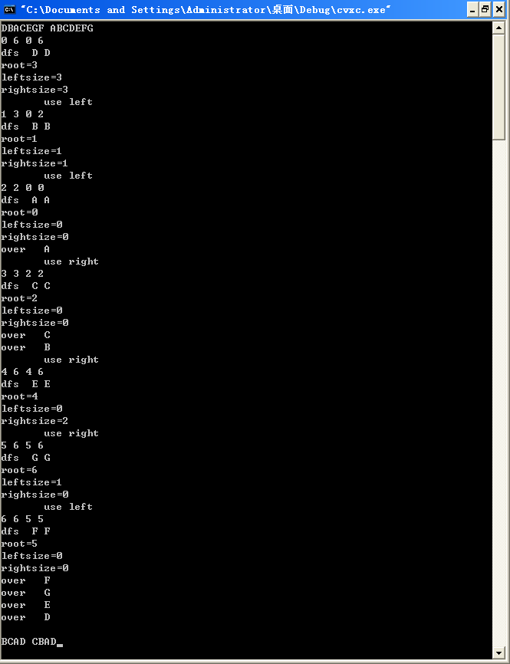

测试代码
#include <cstdio>
#include <cstring>
#include <iostream>
using namespace std;
#define N 27
char pre[N],in[N];
int id[N];
void print(int preleft,int preright,int left,int right)
{
cout<<preleft<<" "<<preright<<" "<<left<<" "<<right<<endl;
int root=id[pre[preleft]-'A']; cout<<"dfs "<<pre[preleft]<<" "<<in[root]<<endl;
cout<<"root="<<root<<endl;
int leftsize=root-left; cout<<"leftsize="<<leftsize<<endl;
int rightsize=right-root; cout<<"rightsize="<<rightsize<<endl;
// cout<<preleft+1<<" "<<preleft+leftsize<<" "<<left<<" "<<root-1<<endl;
if(leftsize) {cout<<" use left "<<endl; print(preleft+1,preleft+leftsize,left,root-1);}
if(rightsize) {cout<<" use right "<<endl;print(preleft+leftsize+1,preright,root+1,right);}
cout<<"over "<<pre[preleft]<<endl;
}
int main()
{
while(cin>>pre>>in)
{
for(int i=0;in[i];i++) id[in[i]-'A']=i;
int len=strlen(in);
print(0,len-1,0,len-1);
cout<<endl;
}
return 0;
}

AC路漫漫 根本想不出来 还要多体会
可以试一试由中序遍历 后序遍历 推出前序遍历 需要对 树的结构非常清楚 多多思考吧

#include <iostream>
using namespace std;
char s1[10001],s2[10001];int len;
void DFS(int preleft,int preright,int left,int right)
{
int i;
for(i=0;i<len;i++)
if(s1[preleft]==s2[i]) break;
int restleft=i-left;
int restright=right-i;
if(restleft>0)
{
DFS(preleft+1,preleft+restleft,left,i-1);
}
if(restright>0)
{
DFS(preleft+restleft+1,preright,i+1,right);
}
cout<<s1[preleft];
}
int main()
{

while(cin>>s1>>s2)
{
len=strlen(s1);
DFS(0,len-1,0,len-1);
cout<<endl;
}
return 0;
}

